# NCPL

# Nachiket Prajapati

# Batch C19

# Azure Project - Data Flow Screenshots

## Dataflow till Delta File Output

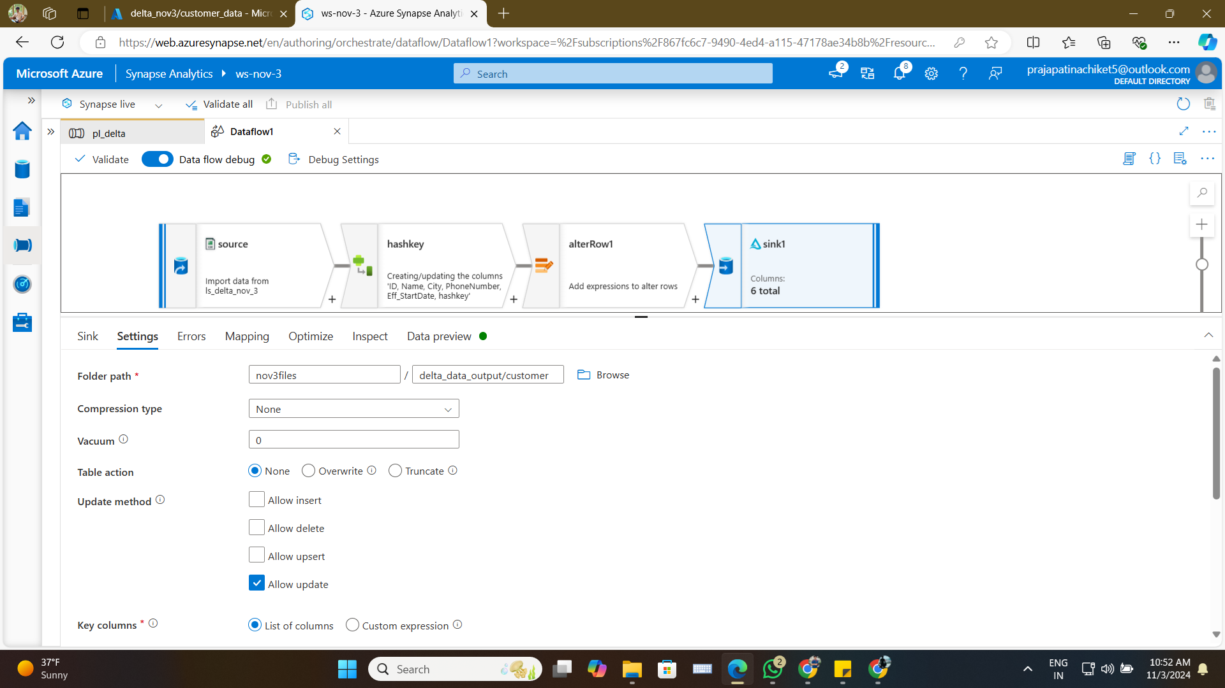

## Added One More Data and Ran Again

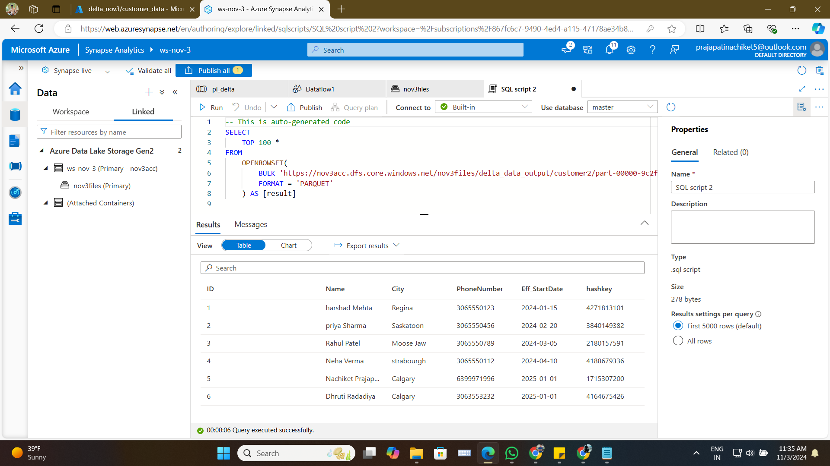

## Dataflow Succeeded

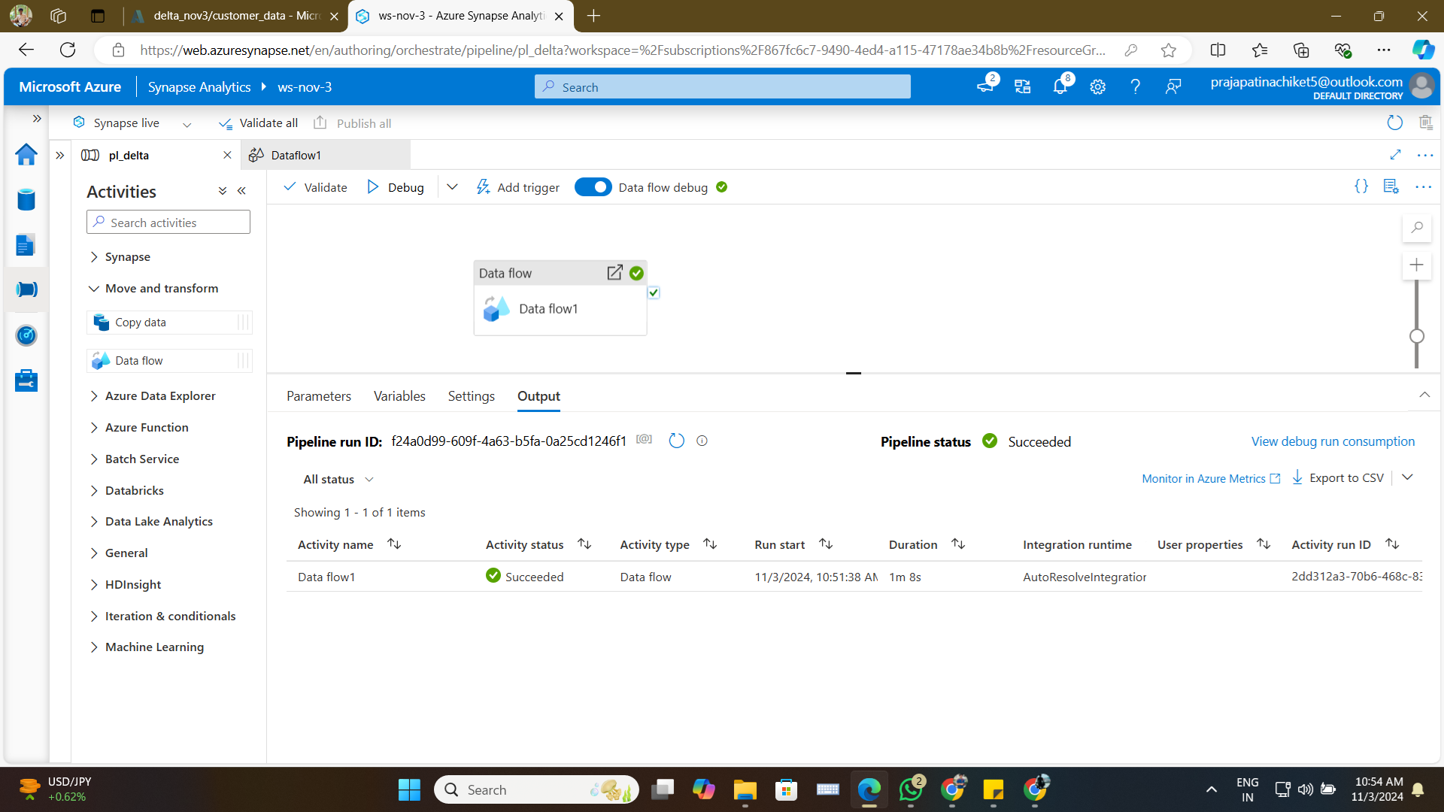

## Dataflow Alter Row Settings

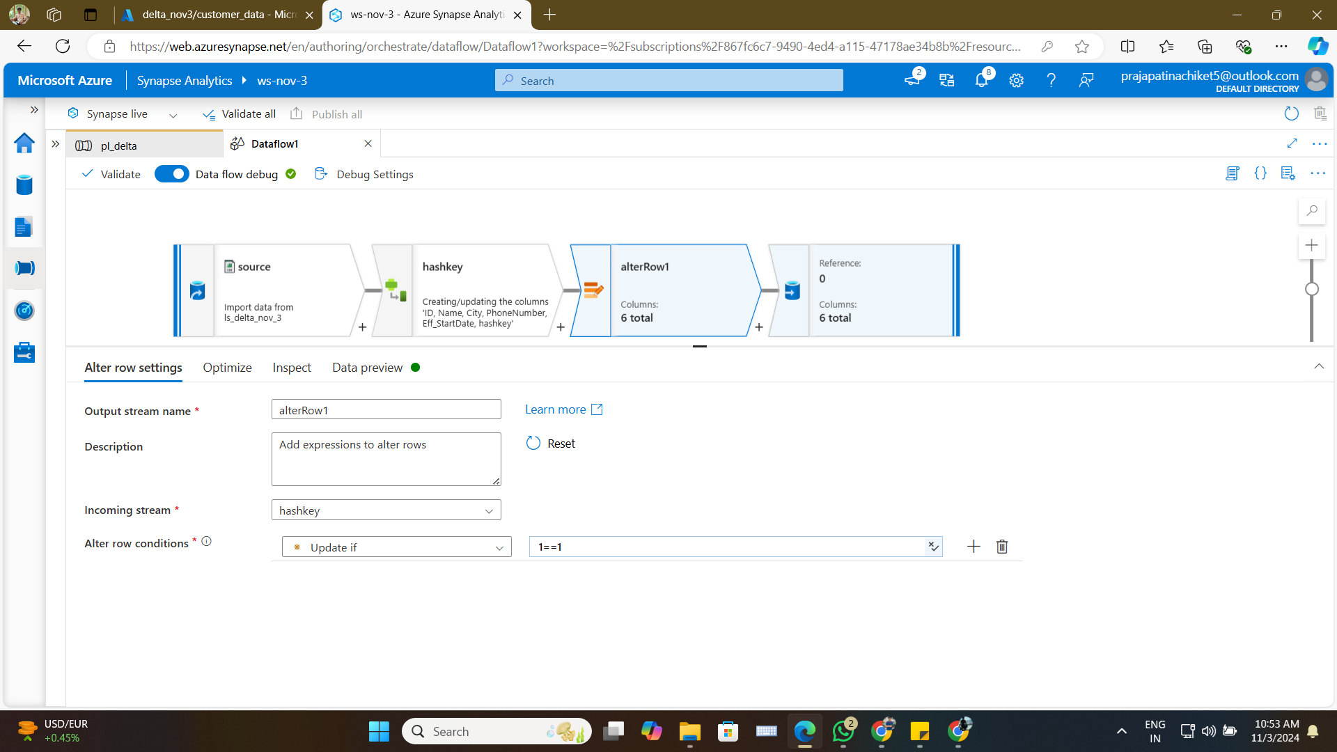

## Dataflow Sink Settings

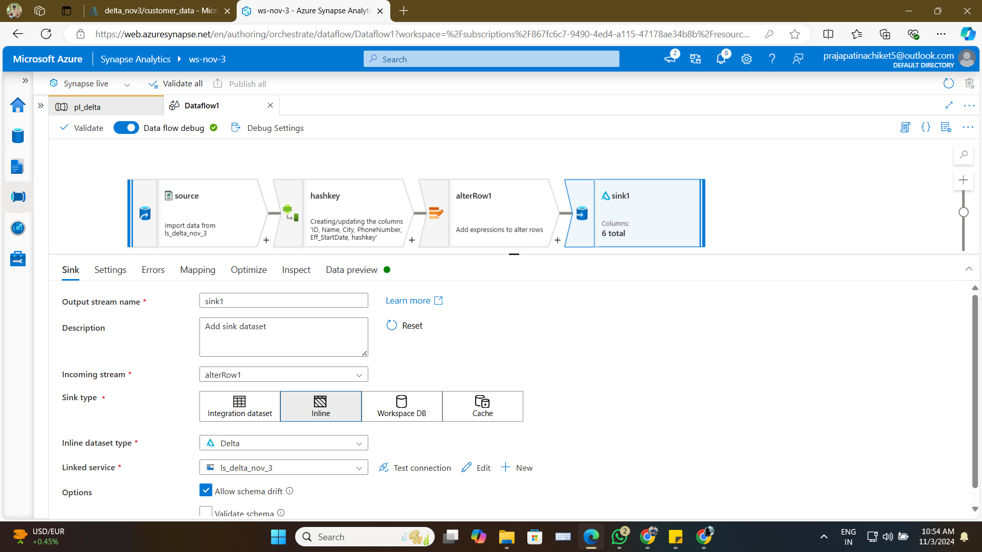

## Dataflow Source Projection Data Preview

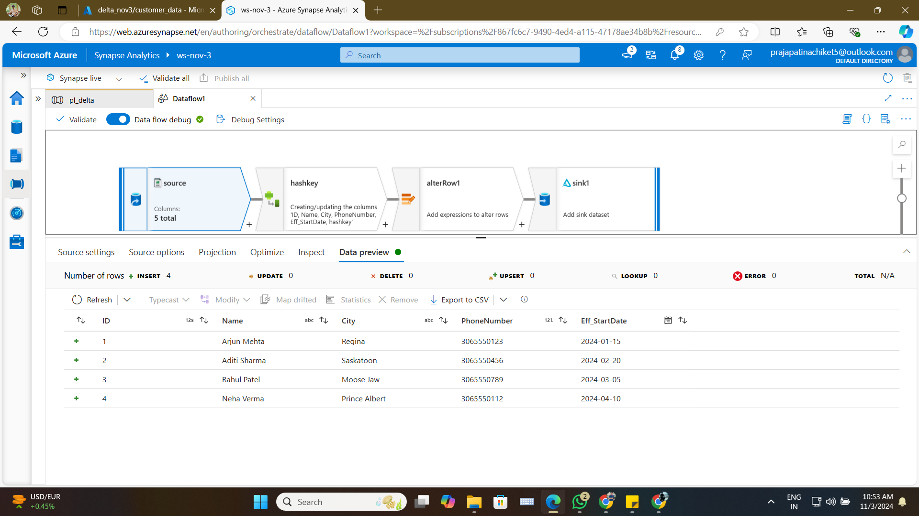

## First Inserted Data

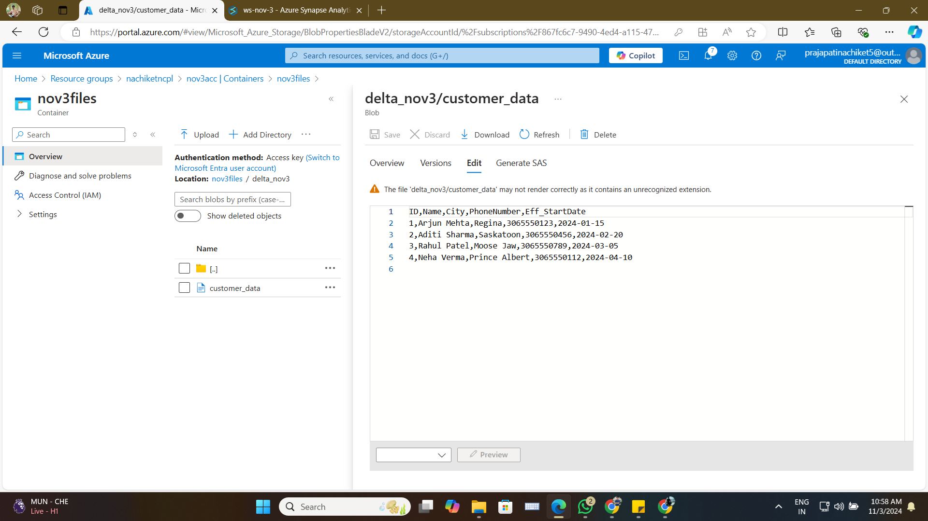

## Last Output with All Data

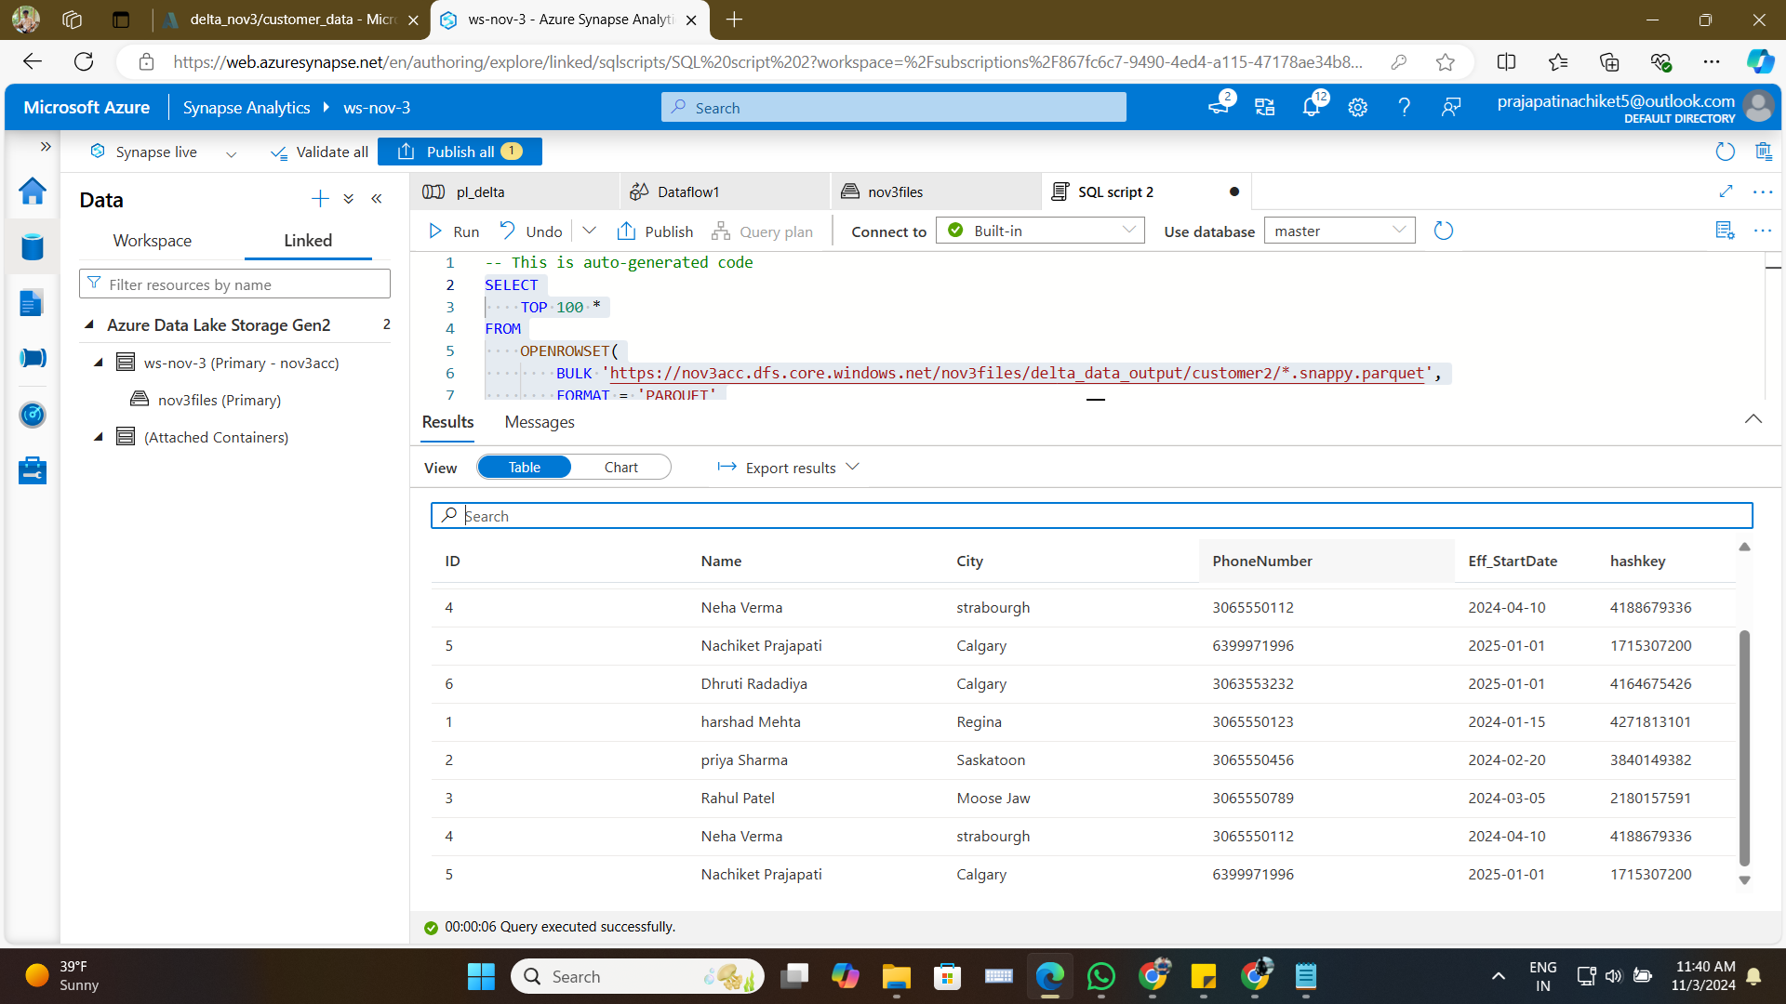

## Output from Serverless SQL Pool after Making Changes in Data File

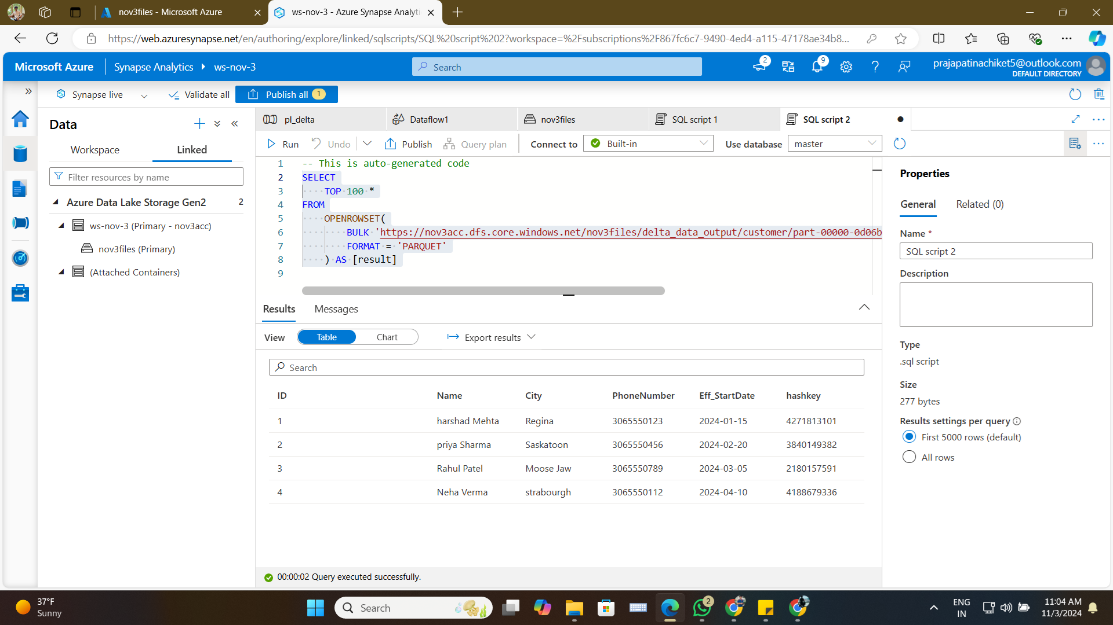

## Output from SQL Pool after Making Changes

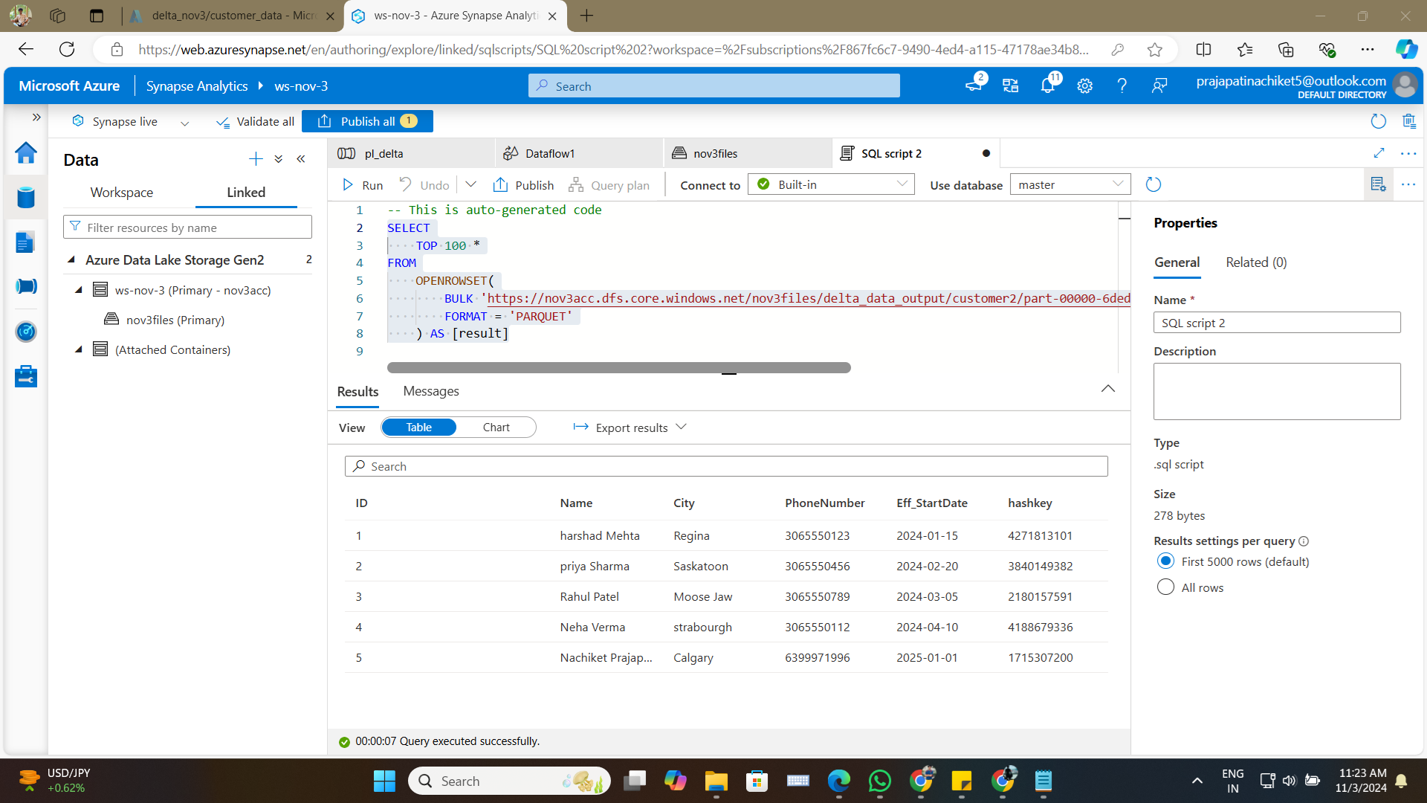

## Serverless SQL Pool Ran the Script

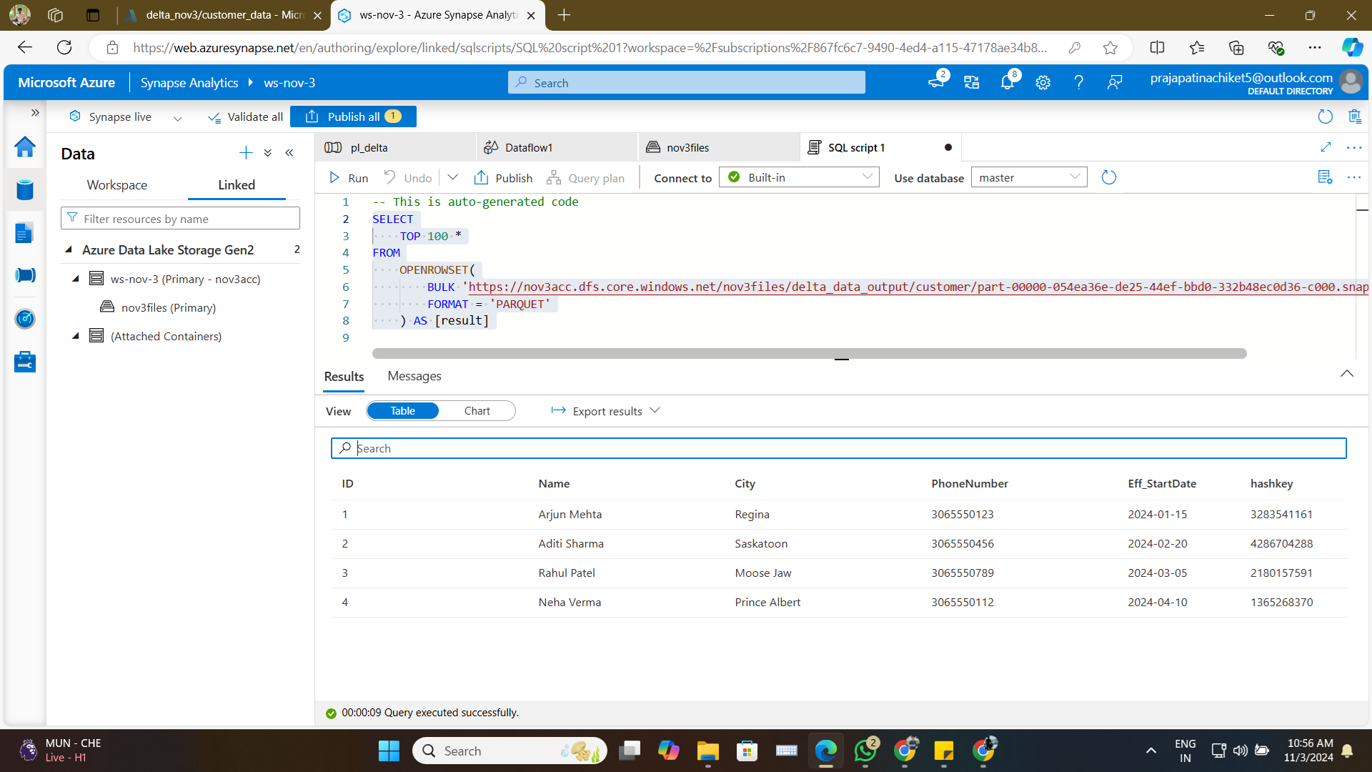

## SSMS - After Updated Data

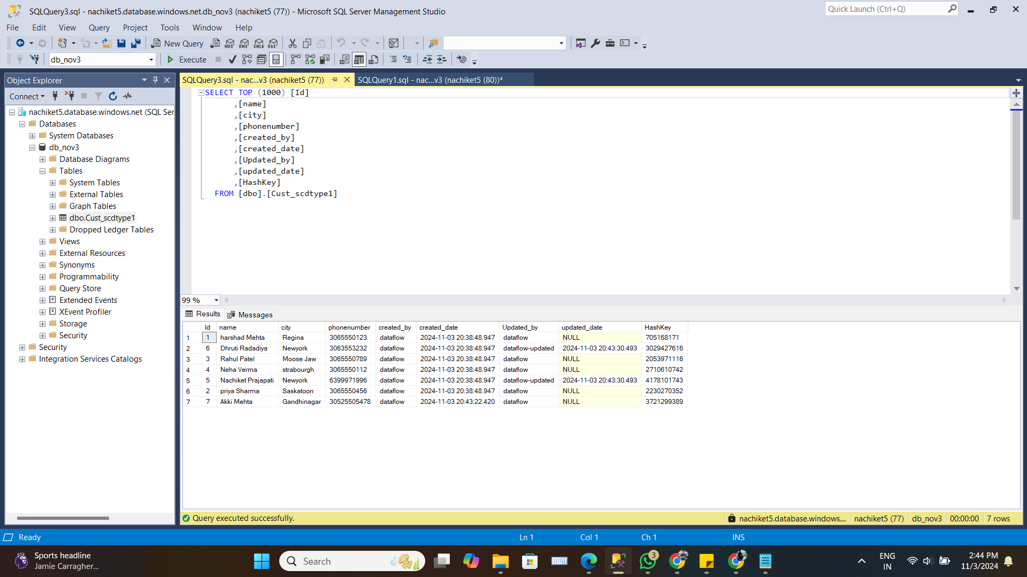

## SSMS Before Update

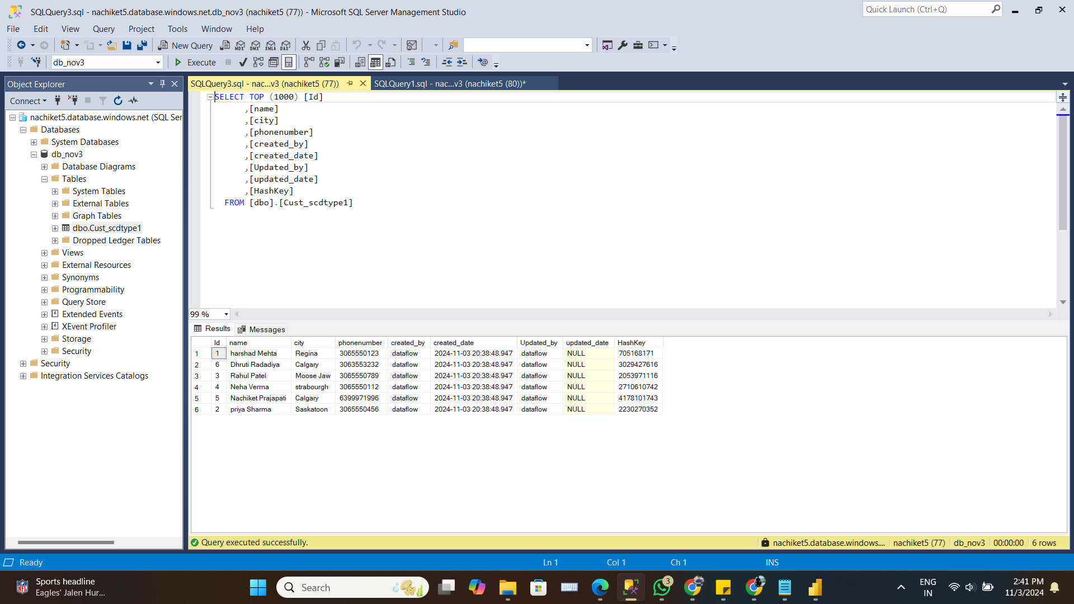

## Succeeded after Making Changes in File

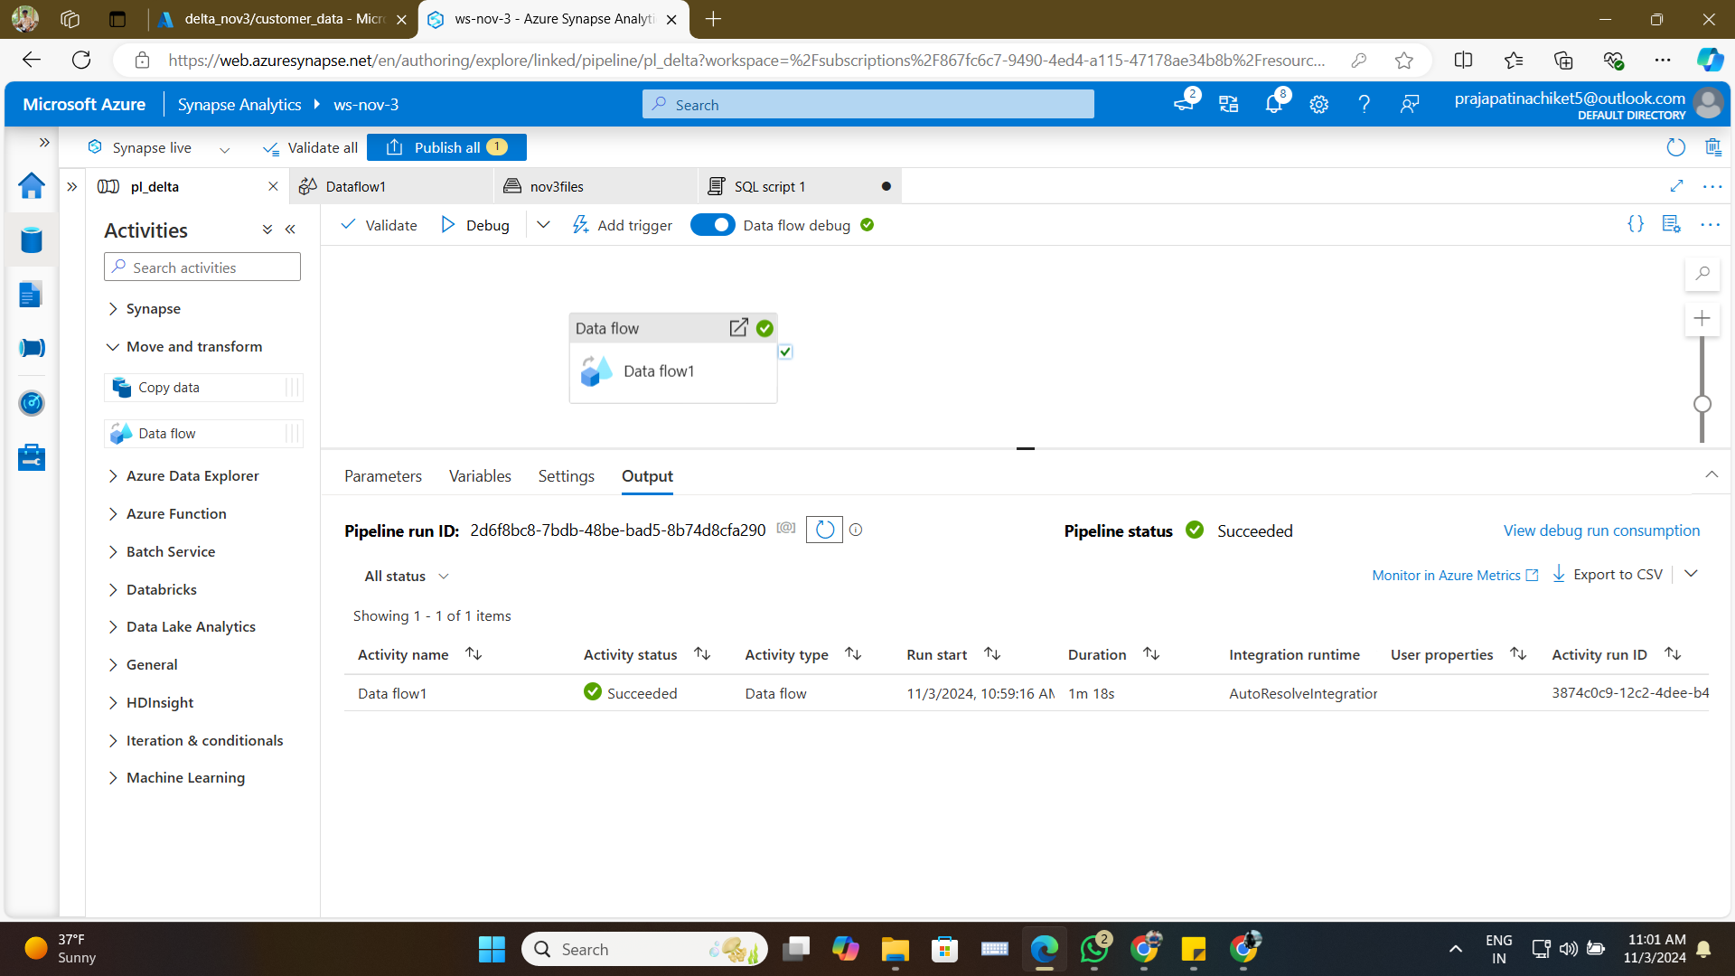

## Succeeded Dataflow with SCD Type 1

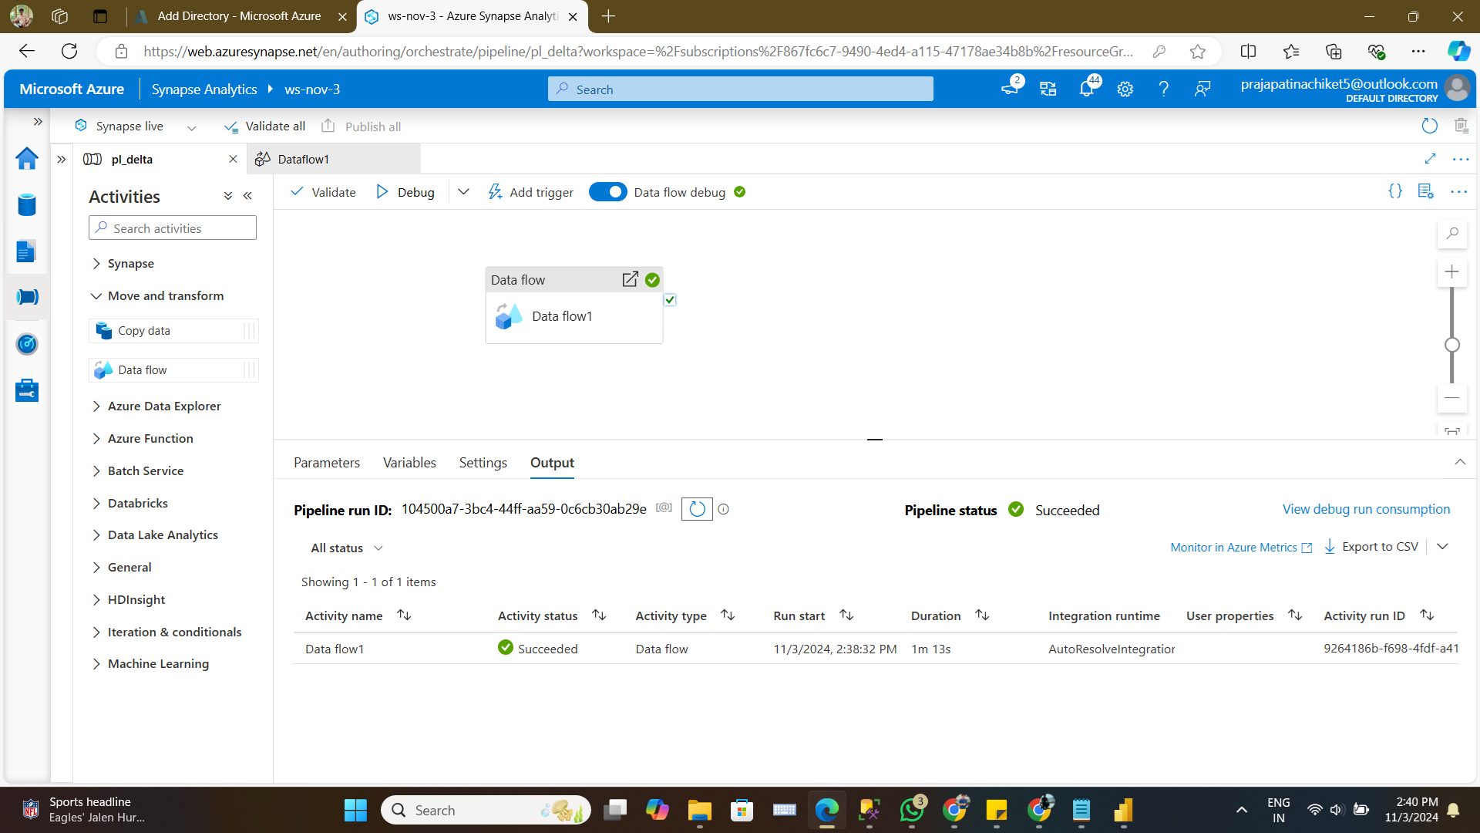

## Updated Data in File

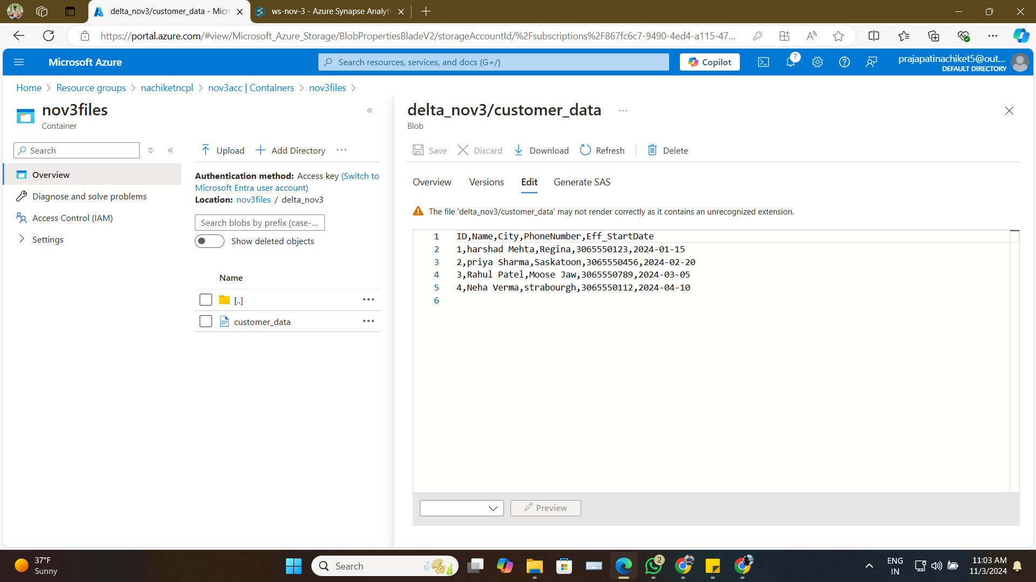

## Whole Dataflow for SCD Type 1

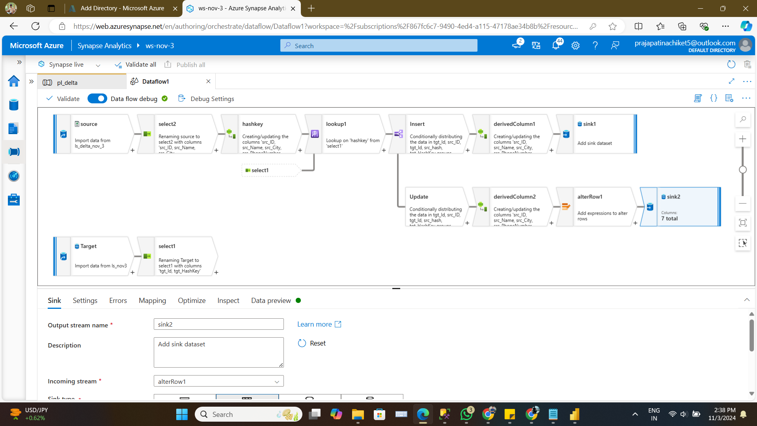

## Azure Delta File Format

The Delta file format, often used with Azure services like Azure Synapse Analytics, provides a robust data storage   
solution optimized for big data and real-time analytics. It combines the advantages of a transactional database   
with the scalability of cloud storage, allowing users to perform ACID-compliant transactions on large datasets.   
This format supports both batch and streaming data processing, ensuring data consistency and enabling efficient   
data updates, inserts, and deletions. Using Delta format, data engineers can manage Slowly Changing Dimensions   
(SCD) and incremental data loads effectively, making it a popular choice for modern data warehousing and ETL workflows   
in cloud environments.